MATH 101 SEQUENCES AND SERIES
CHAPTER 6 TEST

PART I – MULTIPLE CHOICE (CIRCLE THE BEST ANSWER)

- Find the value of the 50th term in the arithmetic sequence 4, 9, 14, . . .
- 249 | - 250 | - 254 | - 6325 | - none of these
- Give the number of terms in the sequence 3, 6, 9, . . ., 144
- 47 | - 48 | - 49 | - 50 | - none of these
- The n^{th} term of the sequence 11, 8, 5, 2, . . . is given by:
- n-3 | - 11-3n | - 14-3n | - 3n-11 | - none of these
- What term of the geometric sequence 3, 6, 12, 24 is 384?

- 6th | - 7th | - 8th | - 9th | - none of these
- The next term in the sequence 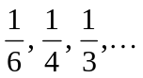 is:

-  | - 1 | - 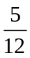 | - 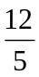 | - none of these
- The n^{th} term of the sequence 8, 16, 32, . . . is:
- 8^{n} | - 2^{n} | - 2^{n+2} | - 16^{n-1} | - none of these

- 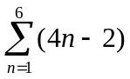

- 24 | - 48 | - 72 | - 102 | - none of these
- 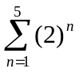
- 34 | - 62 | - 126 | - 63 | - none of these
- If the general term of a sequence is 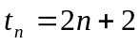, then find the sum of this sequence in terms of n: That is find 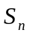:
- n(n+8) | - n(n+2) | - n(n+3) | - n²+4n | - none of these
- The sum of a geometric series with 7 terms is 508. If the ratio is 2, the first term is:
- 2 | - 3 | - 4 | - 5 | - none of these
- The sum of an infinite geometric series 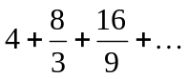is
- A number between 0 and 6 | - 12 | - 18 | - 24 | - infinite
- If the 7th term of a geometric sequence is 256 and the first term is 4, then the 5th term is:
- 16 | - 32 | - 64 | - 128 | - none of these

- If 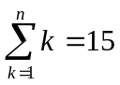, solve for n
- 1 | - 5 | - 10 | - 15 | - none of these
- Find the sum of the areas of an infinite sequence of squares. The lengths of the successive squares are 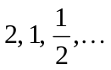
- 4 | - 8 | - 16 | - 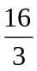 | - infinite
- For a certain series 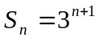, determine the third term, t₃.
- 18 | - 9 | - 3 | - 54 | - 81
- When simplified, the product 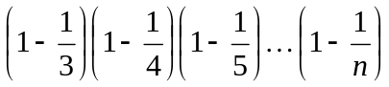 is
- 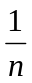 | - 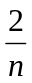 | - 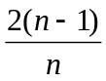 | - 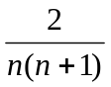 | - none of these

PART II – PROBLEMS – SHOW ALL YOUR WORK FOR FULL MARKS. NO MARKS FOR GUESSING. (THREE MARKS EACH)

- Determine the value for k for which 3k-2, k+1, 2k-5 forms an arithmetic sequence.
Answer ________________
- The seventh term of an arithmetic sequence is 21 and the twelfth term is 14, determine the first term.
Answer ________________
- The third term of a geometric sequence is 5 and the eight term is 160. Determine the first term.
Answer ________________
- Three consecutive terms of a geometric sequence are respectively 4x-2, x+1, and x-3. Find x.
Answer ________________
- An air pump removes 8% of the air per stroke, in a sealed container.

  - How much air remains in the container after three strokes?
Answer ________________
  - How many strokes are required to remove 50% of the air? (round to one decimal place)
Answer ________________
- You invest $400 at the beginning of each month for a total of 10 years. Money is worth 9% p.a. compounded monthly. What is the future value of your investment in 10 years?
Answer ________________
- A person about to retire has $250,000.00 in her financial portfolio. If money is worth 6% p.a. compounded monthly, how much per month can she expect for a 20 year fixed annuity?
Answer ________________

- The sum of the first two terms of a geometric sequence is 36, the product of the first and third terms is equal to nine times the second term. Determine the sum of the first four terms.
Answer ________________
BONUS
- Solve for k – you must show your work.
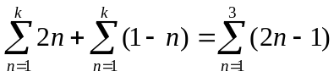
or
- Find the values of x for which the geometric series 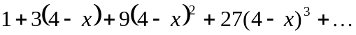 has a finite sum

